Bacchus Winery
We are part of Team Blue and for our case study we decided to choose the Bacchus Winery Case. Our team members are Robert, Sara and Carolina. Robert contributed the business rules, the initial ERD, and prepared a report for how many hours each employee worked during the last quarter. Sara contributed updates to the initial ERD and database, while preparing a report on supplies delivery time and any gap between expected delivery. Carolina contributed updates to the business rules and initial ERD and prepared a report on which distributor orders which wine, which wine sold, and which didn’t. Together we prepared this presentation and took note on the assumptions we made during this project.
The case study involves helping Bacchus Winery with their operations team by creating a database system to track suppliers, wine production, inventory, distribution and employee hours. The owners need accurate reports on supply deliveries, wine sales and employee work time to make sure their winery is running according to budget.
Our objective was to design a database structure, create exact reports and ensure data is clear for new decisions.
Here is our finalized ERD broken down into 3 pieces for better visibility.
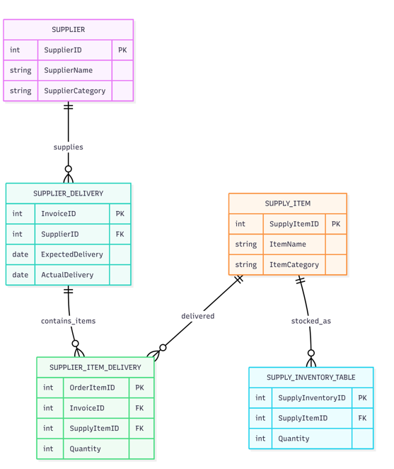
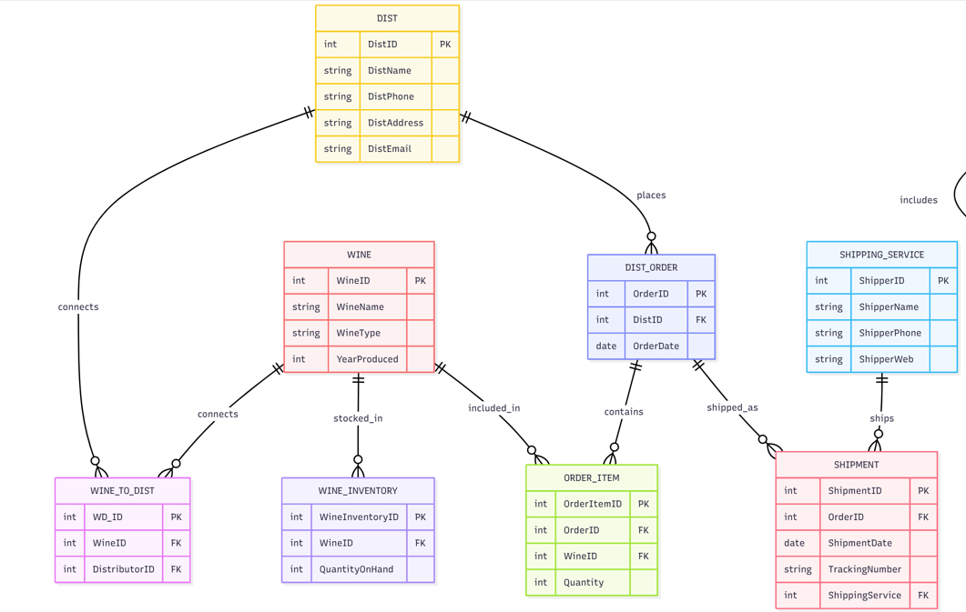
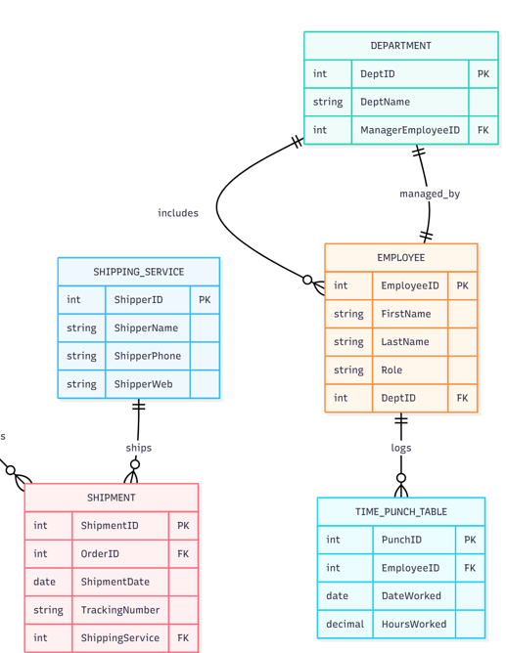
We organized and finalized the ERD in 3 sections, one being supplier, supplier delivery and supply items. Second being distributor, wine, distributor order, inventory, order item and shipment. Lastly the third being departments, employees and hours worked by employees. Each table was necessary to help create each specific report.
For the report used for calculating which distributor carried which wine, what wine was sold, and what wine was not selling, we needed the wine table, the distributor table, the quantity ordered, year produced and distributor name.
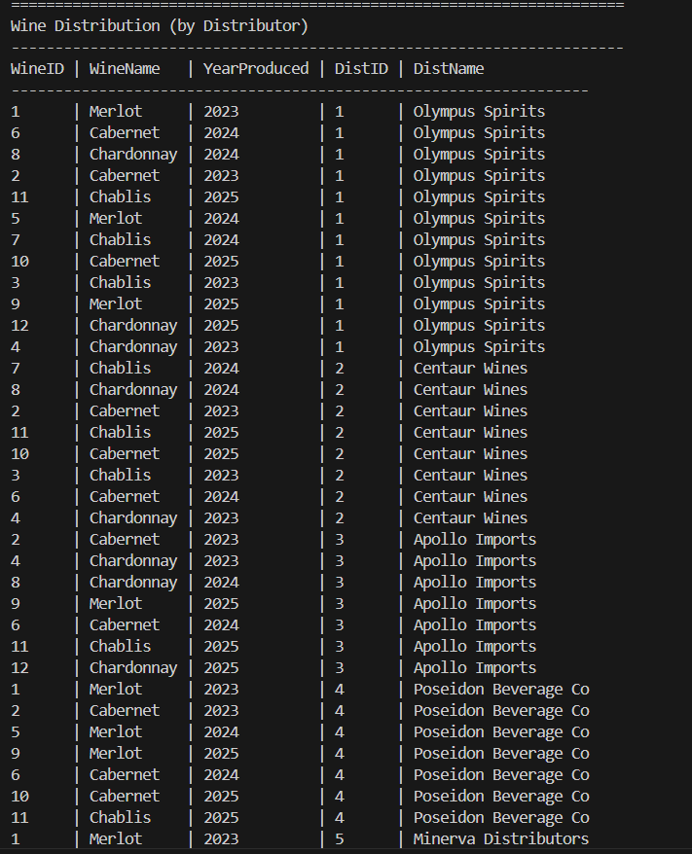
Here is the report for each wine each distributor carried:

Here is the report for total wines sold and wines that haven’t sold: 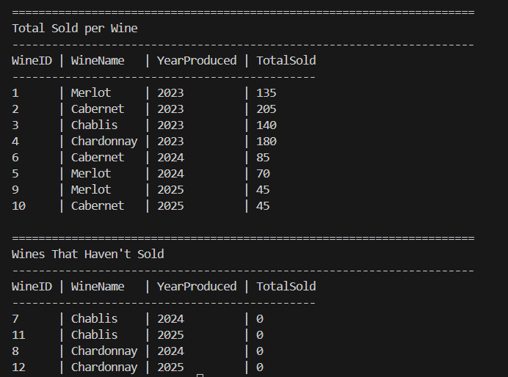
Assumptions made from these reports included the same wines have “aged” differently. Without the information for the year the wine was produced, we would have incomplete data and be unable to know which year is not selling and which is. Based on the wines that haven’t sold report, we can locate Chardonnay 2024, 2025 and Chablis 2024, 2025 are not fan favorites from our distributors.

